# **Cal Farrell – UDK Project**

When I first began my udk project, I was working from the start with nothing in it except a level created spawnpoint, a skybox, a lightimportancevolume object and a texture brush.

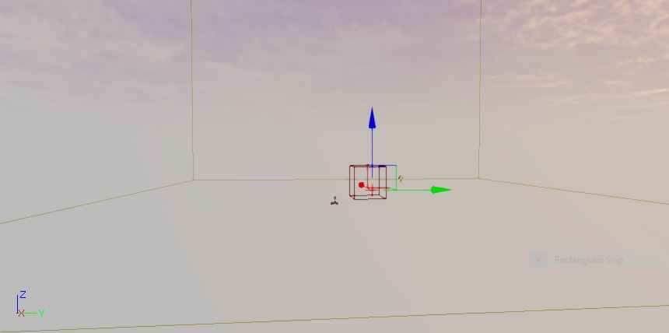

Figure 1: A newly created udk project

First, I began to create the level terrain. To do this, I went to Tools > New Terrain, a dialog window appears with a location option on one side and a patches option, which is size and resolution, on the other.

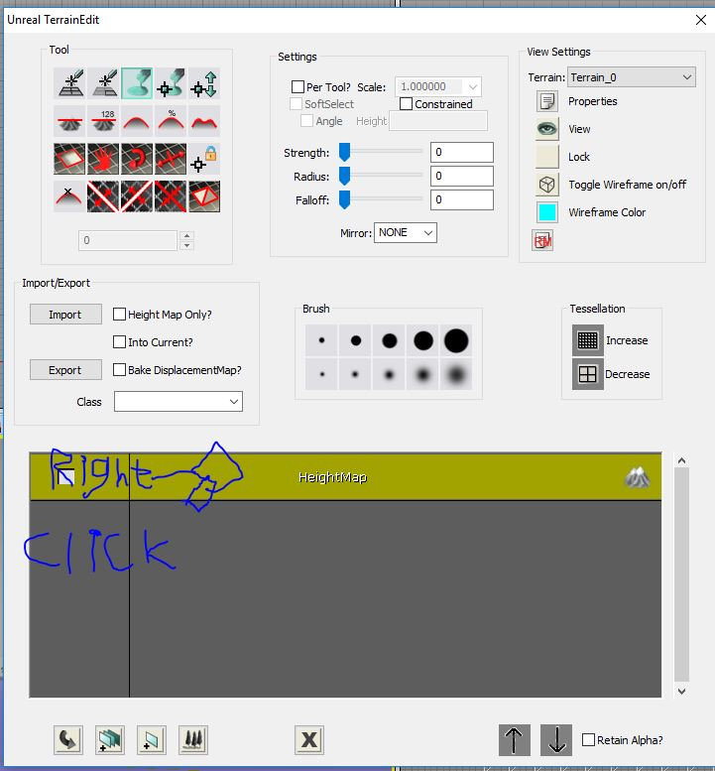

Figure : Terrain editor menu

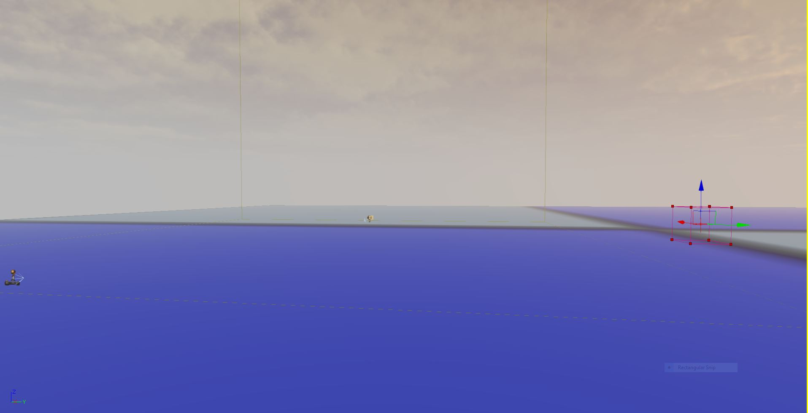

Figure 3: A new untextured terrain

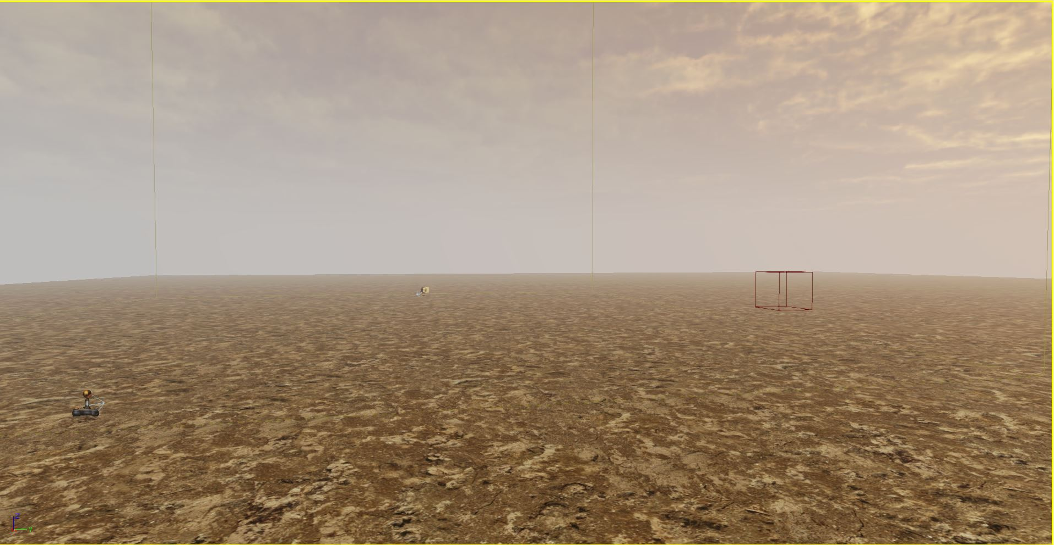

Figure 4: Textured terrain

I set up a new terrain layer and texture to make my terrain look the way I wanted it, by going to the modes tab on the left side of udk editor, clicking terrain editing mode, right-clicking on heightmap in the centre of the screen and clicking new terrain setup layer from the drop-down menu. After, right click new layer and select new terrain material from the drop-down menu. Select a new material by going to the content browser, drag it onto the material.

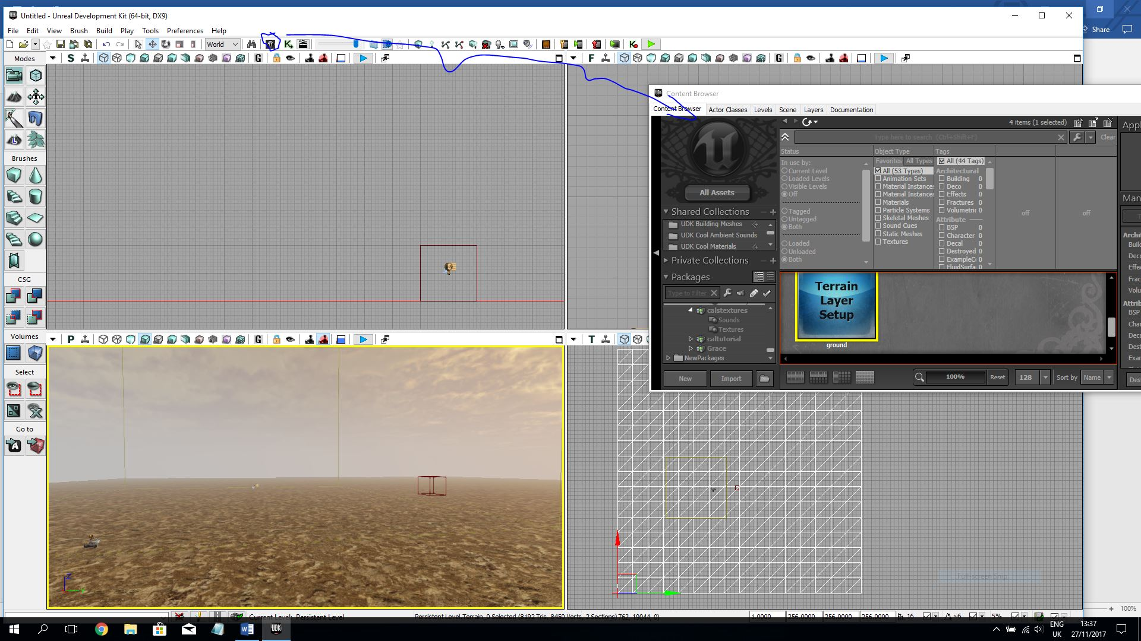

Figure 5: Content Browser

I then proceeded to building structures. First, I right-clicked on the cube brush shape on the left of the screen, set the x, y, z values to: x, 1024, y, 1024, z, 800, and click build. When finished I closed the cube dialog box, I aligned the brush where I wanted it on the terrain. And clicked CSG add.

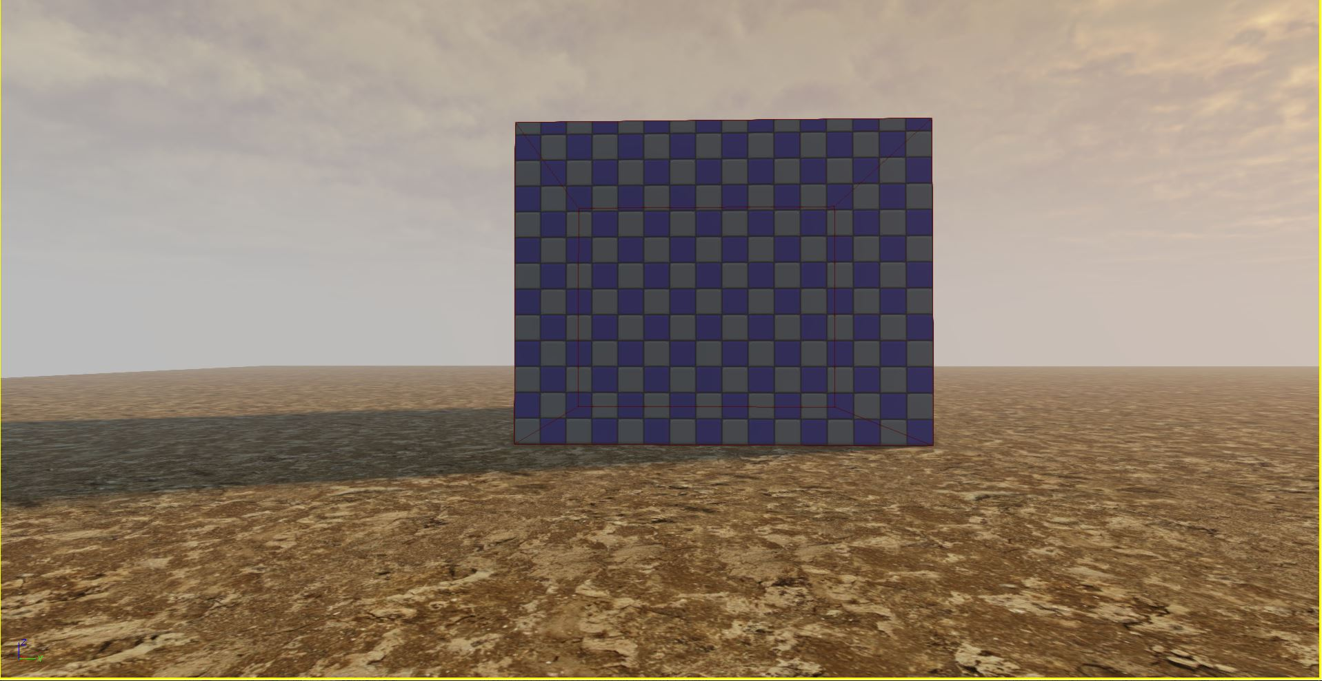

Figure : a building CSG cube

Afterwards, I hollowed out my box so that I could enter it in my game, I did this by creating a slightly smaller box and cutting some of the boxes layers away with it, to achieve this, I had to take 32 from x, y, and z, and clicking CSG subtract; beside CSG add button. 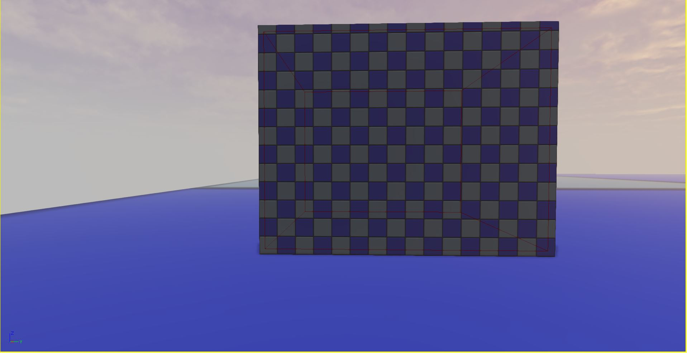

Figure : CSG subtraction method

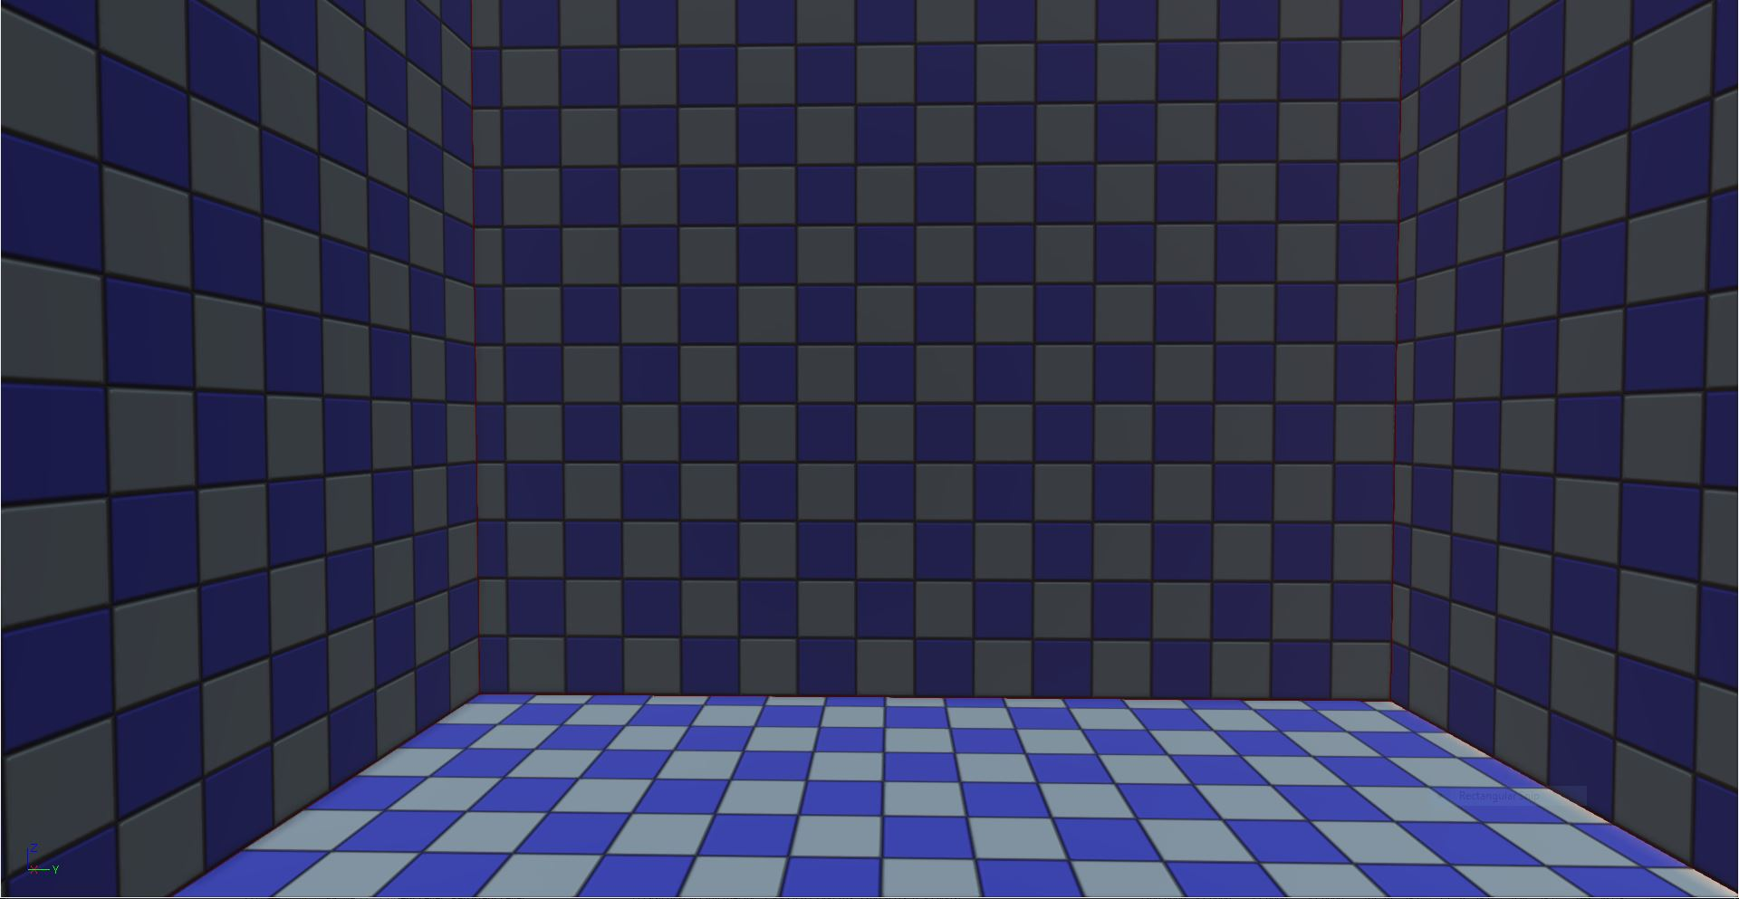

Figure : CSG subtraction result

Then, I made a hole for a doorway the measurements being: x, 192 y, 16 z, 192.

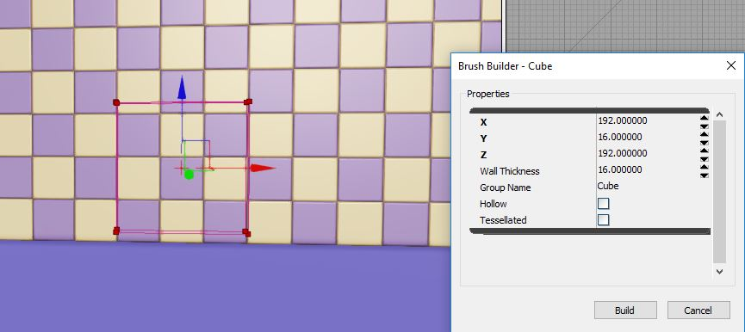

Figure : Door measurements

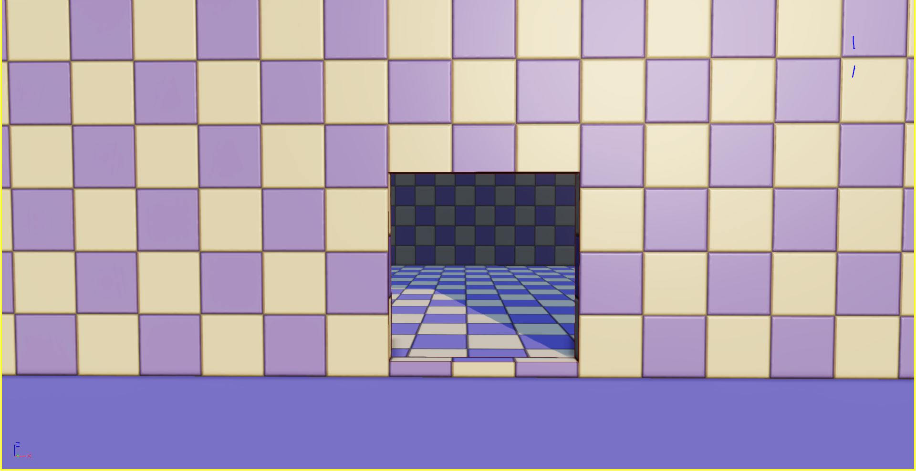

Figure : doorway

I built the second-floor landing after that, the measurements being, x, 992 y, 992 z 16.

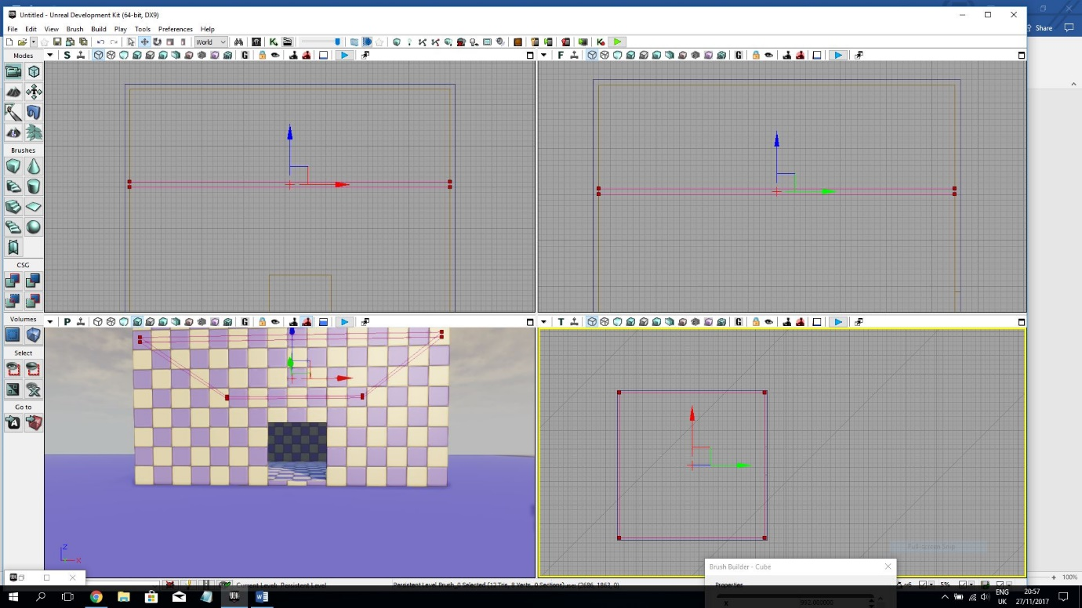

Figure : landing measurements-alignments

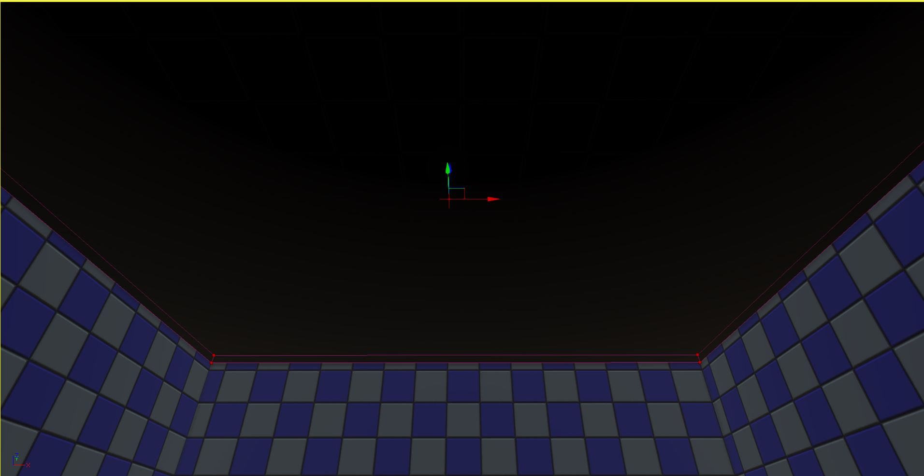

Figure : the landing

I needed steps up to the landing at this point, so, I made a hole in the side of it for my stairs.

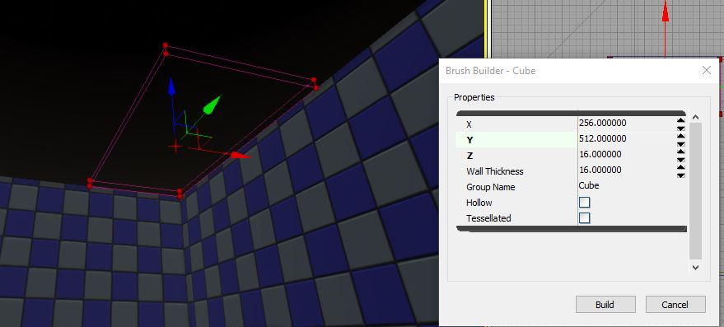

Figure : measurements for landing hole

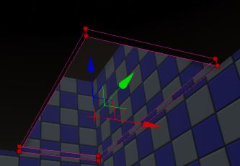

Figure : hole in landing

Next, I made the stairs for the landing. The measurement system on the stair brushes are a little different from the cube.

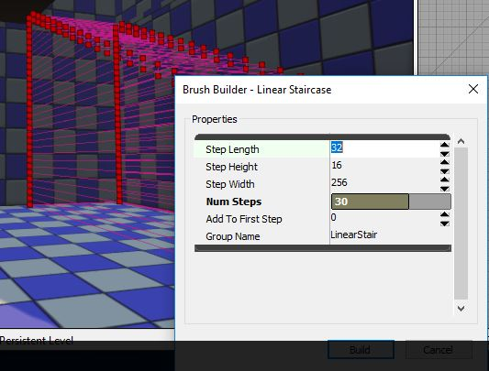

Figure : linear-stair-brush

I used 30 steps in the process of building the stairs which matched with the floor and ceiling perfectly.

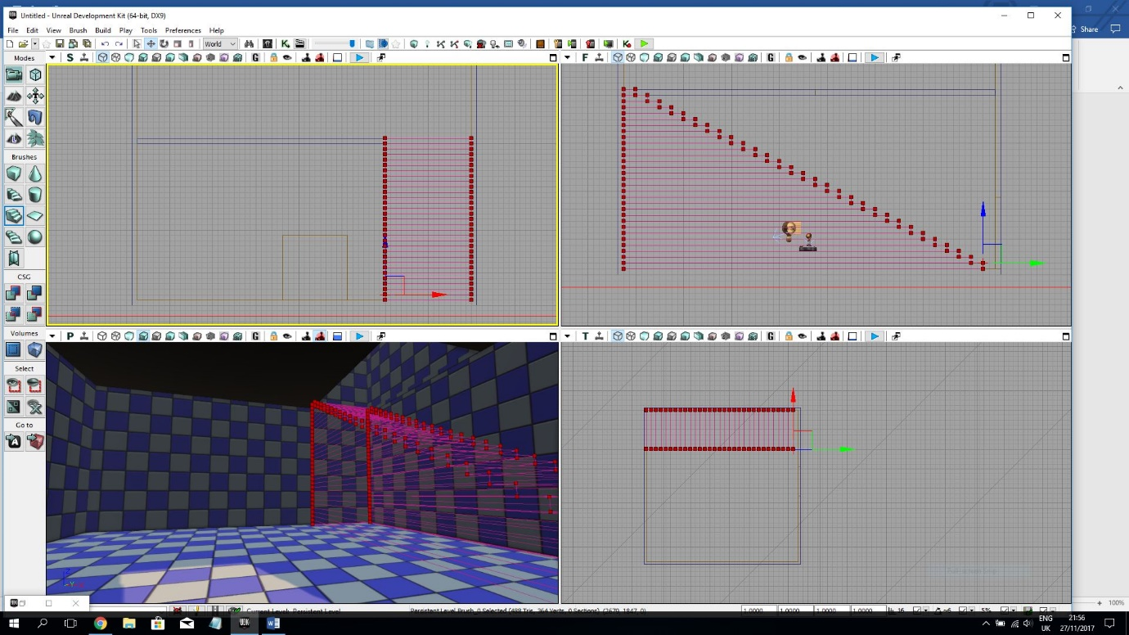

Figure : linear staircase alignments

Next, I clicked CSG add.

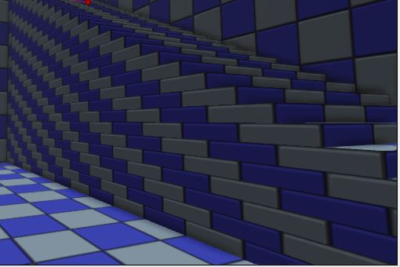

Figure : linear stairs

I realised I also wanted steps up to the roof, so I moved the red brush upstairs and shortened the number of steps by 9 as to fit my stairs to the roof.

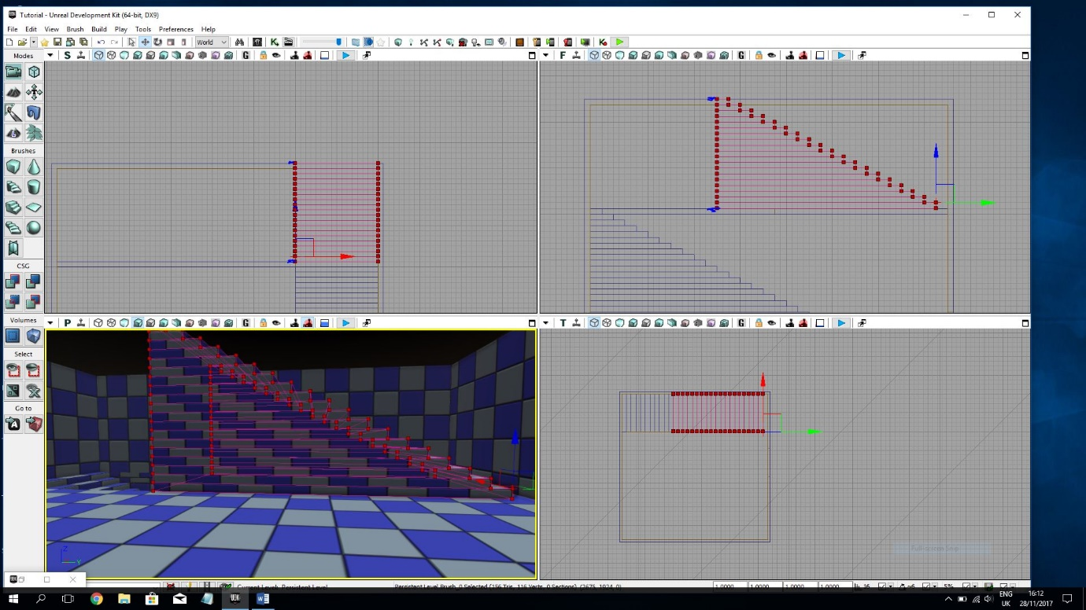

Figure 18: upstairs linear stair-case

Then, I created another hole in the ceiling to my roof.

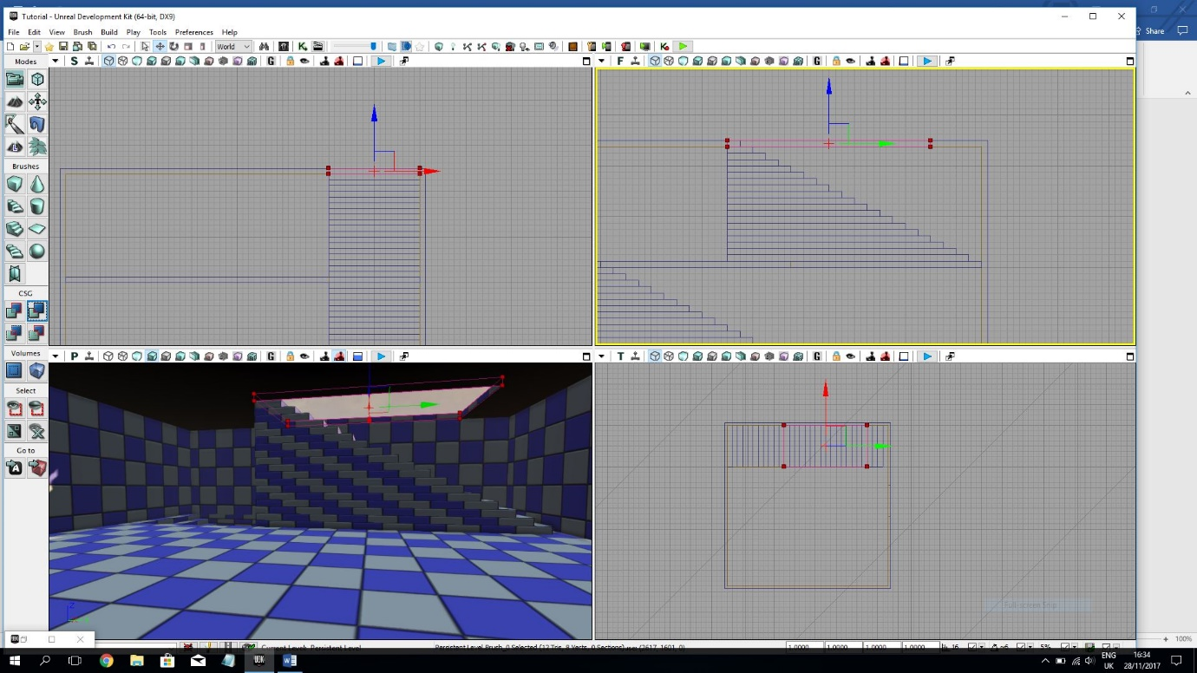

Figure 19: up-stair hole to rooftop

After building the house I textured it using a custom package I created called Calstextures.

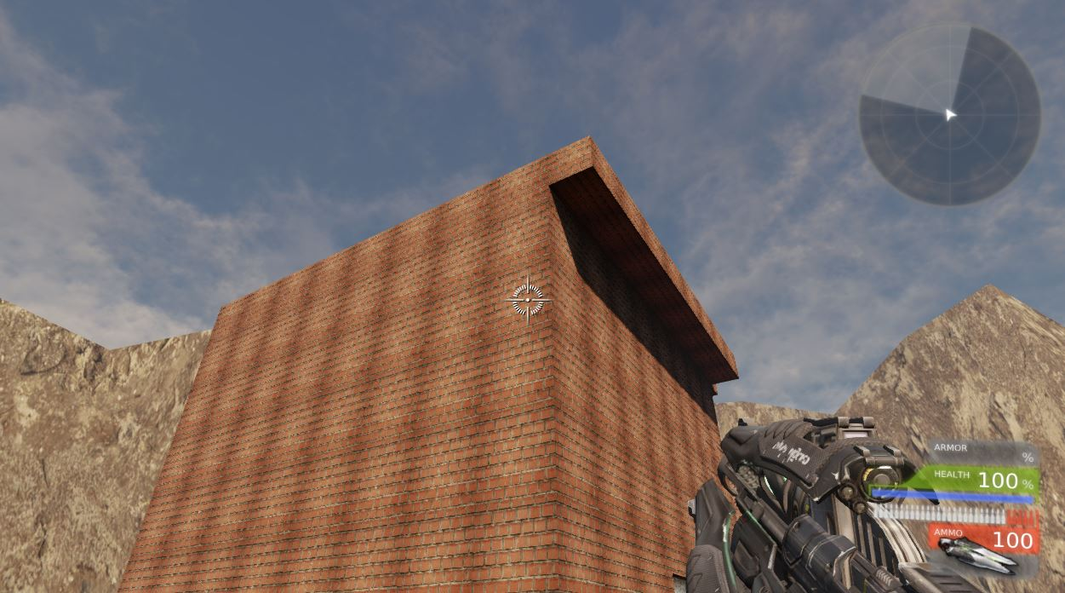

Figure 20: textured building

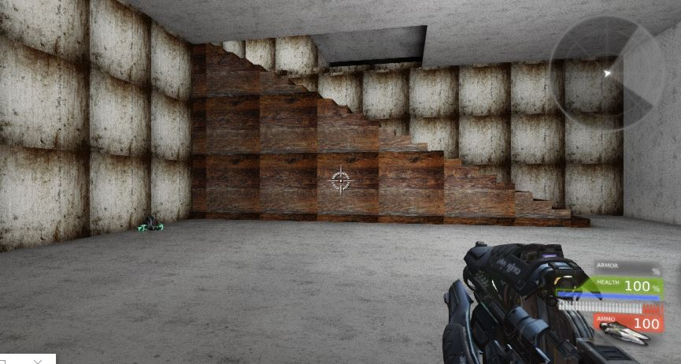

Figure 21: textured inside building

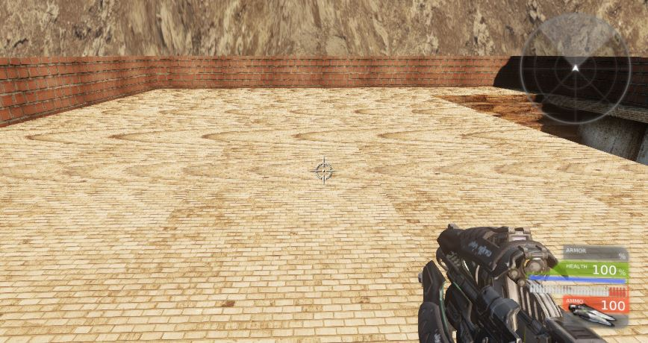

Figure 22: textured rooftop with cover

Once the building was textured, I copied and pasted it 9 times.

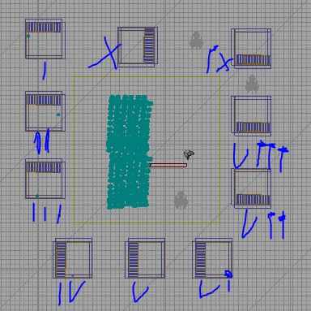

Figure 23: copied buildings

Afterwards, I did the playerstarts or spawnpoints. I right-clicked where I wanted it and went to add actor in the contextual menu and clicked add playerstart.

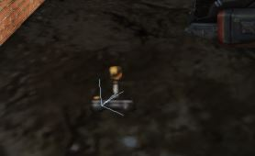

Figure : Spawnpoint